**CONTRACT CLAUSE VERIFICATION**

**PART A: Understanding how to run the application**

1. 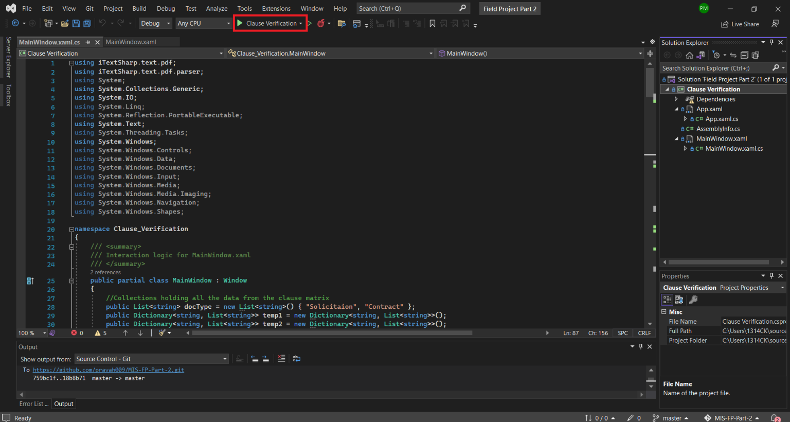If the code is imported successfully and opened with MS Visual Studio, the application should have a similar layout with the project name “Clause Verification,” as annotated above, next to the run code compilation button.

Note: The theme and appearance of the application will differ depending on the users’ choice. This will not affect the code unless a line of section of the code is altered or deleted. Each comment is colored in green, starts with “//” and segregates the different parts of the code.

1. 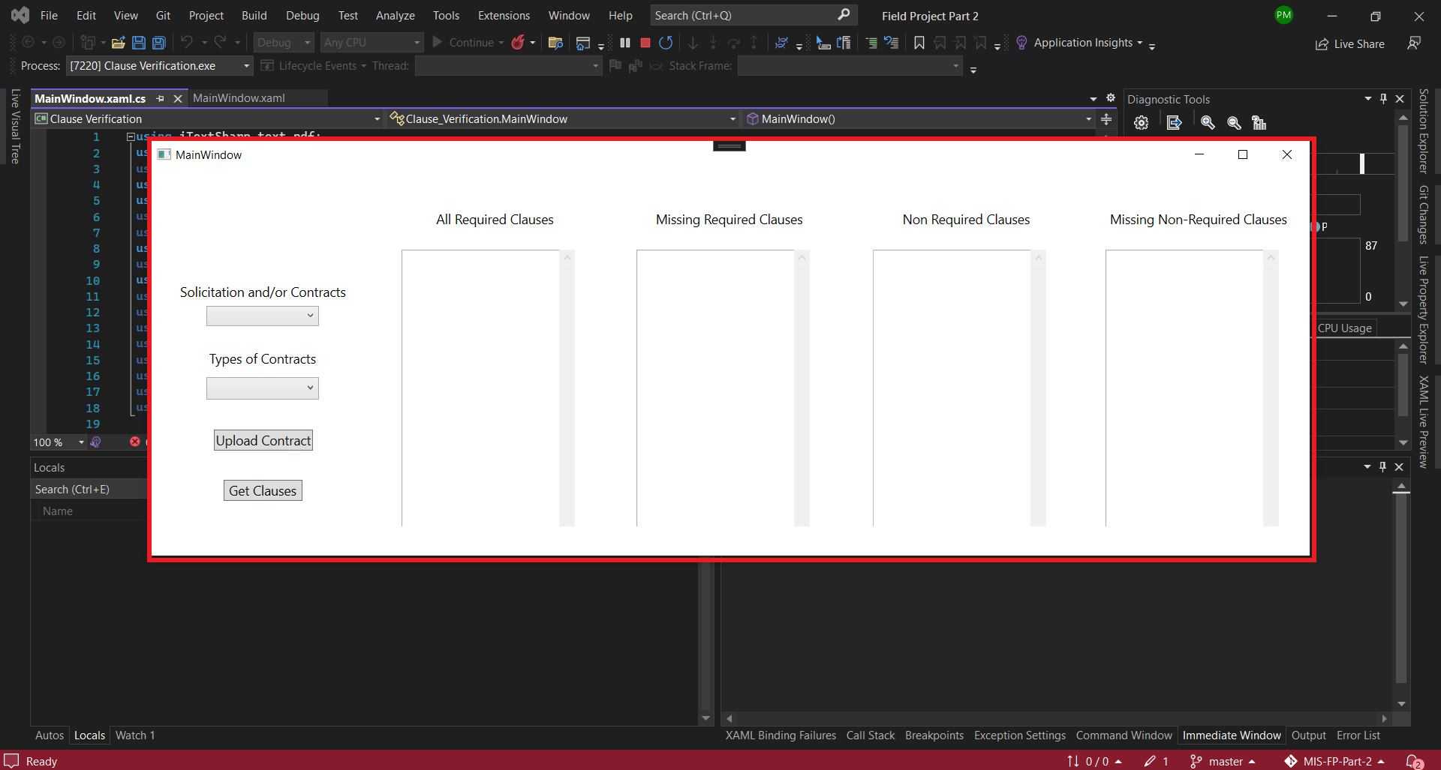After clicking the button annotated above, the WPF application should run and open the main window as given below.
2. The Main Window will have drop-down menus for selection of “Solicitaion and/or Contracts” and “Types of Contracts”. Next we have the “Upload Contract” button to enable the user to upload the drafted contract whose clauses need to be verified using the application. Lastly, the “Get Clauses” button enables the user to execute the operation with the conditional selection.
3. It is imperative to go about the selections from the drop-down menus and the buttons to avoid runtime errors. Below is an example of the execution.
4. 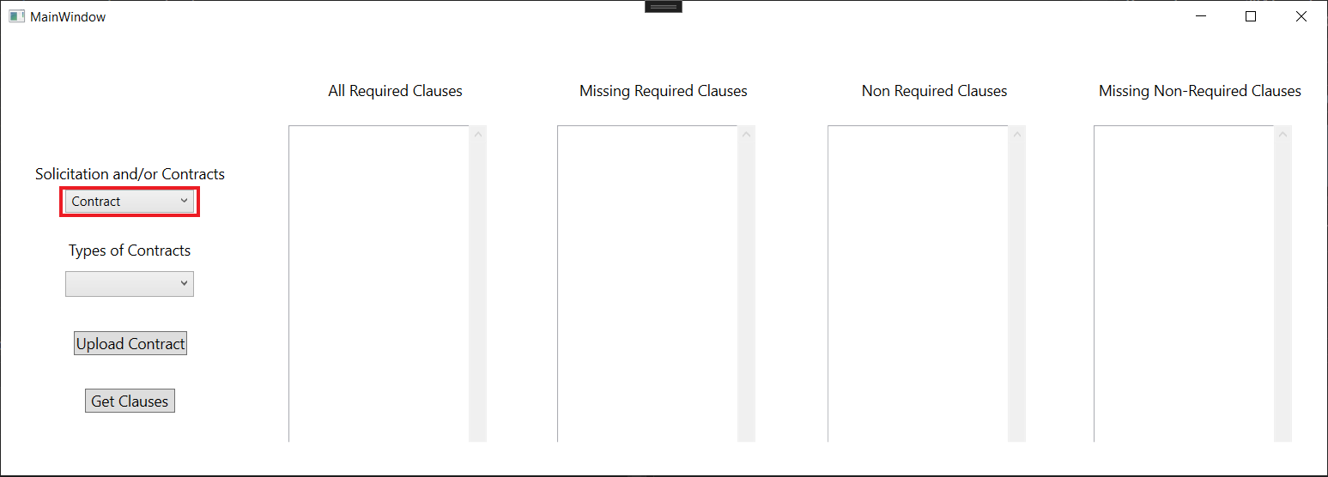Lets say you wish to select Contract verification. Then you select the Contract option in the drop-down menu.
5. 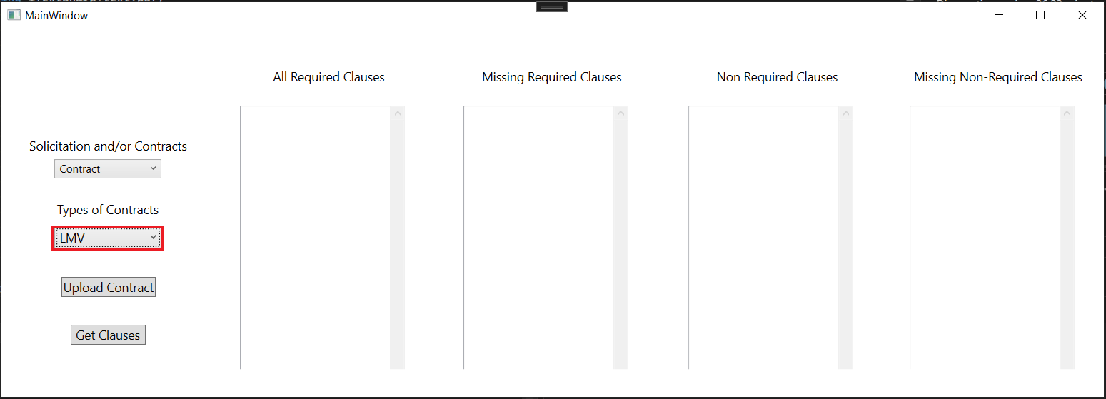Next we select the type of contract we wish to cross-verify the clauses with. Lets say we go with “LMV” contract type.
6. 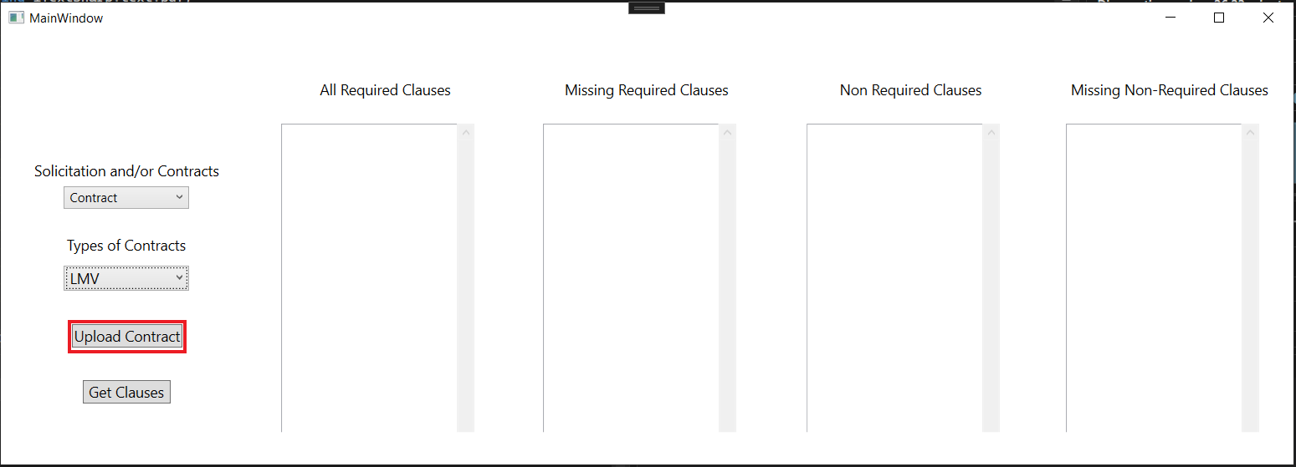Next we have the “Upload Contract” button that open a dialog box for file selection. This function is only build to find PDFs thus it only accepts PDFs to be analyzed.
7. A dialog box similar to the one below should appear with all the PDFs in the selected folder of choice where your desired drafted document is. Select the document of choice and click open for the application ot select the file.

Note: If you wish to reselect a different document repeat the previous step.

1. Now navigate back to the application and click the “Get Clauses” button. This will display the clauses in the respective boxes and their conditonal operation.

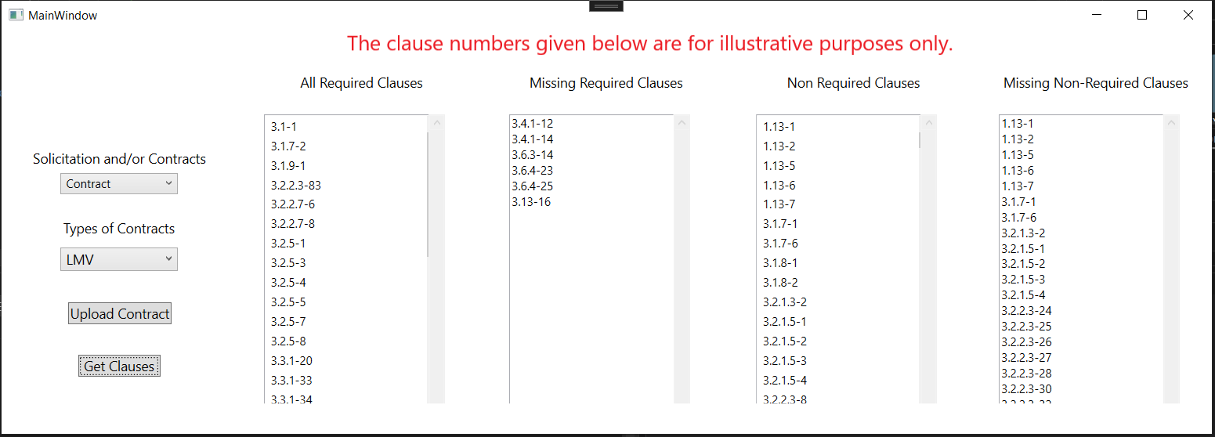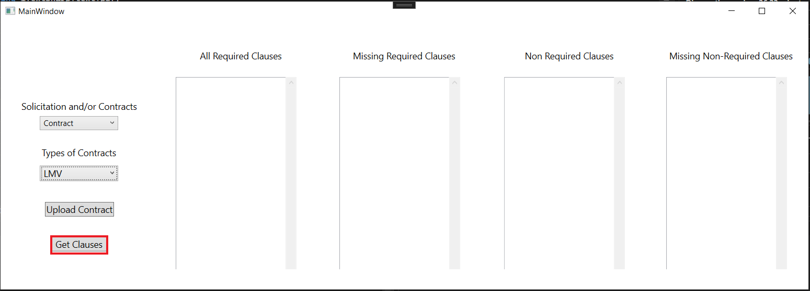

1. If you wish to select another type of contract, change your selection in the “Types of Contract” drop-down box. Upload your document and click the “Get Clauses” button again.
2. If you run into an error at any point, running the application from Step 1 is a full-proof method of arriving at the desired result.